Video Game Sale Trends from 2000 to 2020

The objective of the project is to analyse how video game sales have been for past 20 years, this project will help publishers to choose the right path to increase their sales by considering certain strategies.

**DATA PREPROCESSING**

The dataset for this project contains information on game titles and publishers, sales across different regions, release year, genres, critic ratings, and the consoles the game released on.

The dataset contains different game genres those are Adventurer, Board Game, Fighting, Puzzle, Racing, Shooter, Simulation and Sports. These games were released on PS, DS, IOS, PC, Linux, PS2, PS3, PS4, PS5, PSN.

The dataset contains 13763 rows with 14 featured columns. The below image represents the structure of the data.

During preprocessing the we remove all the null and duplicated values. We need to remove these to eliminate ambiguity in the data. There are rows with same title, publisher and platform published for which introduce ambiguity so need to eliminate these. Encode variables into required format for further analysis like converting genres and console types to factors which is a helpful process for improved analysis.

**Number of games released each year**

The graph indicates a big jump in the number of games released around 2009, with more than 900 games coming out that year. This suggests that the video game industry saw a major increase in activity before 2009. However, after hitting this high point, the number of games released dropped quickly in the following years, which could mean the industry went through a period of getting smaller or changing how it operates.

Before starting the analysis, we will check how video game sales have been over the years. As it can been seen that the overall sales have been increasing over years.

To further our analysis, we will check which genre had more games and which will can be an effective factor of our analysis. From the plot we can see that Adventure had more games compared to all other games following adventure, sports and shooter genres had more games. Whereas Board games were very less.

**Plot for visualising global sales of games in every genre**

The overall plot indicates that overall sales in every genre has increased over the years, from the above plot adventure genre had a greater number of games, the sales in this genre picked up faster when compared to other genres after the downfall.

Even though board games started gaining popularity in between 2010 and 2015 they have reached the benchmark sales of other genres indicating a potential growth in that field.

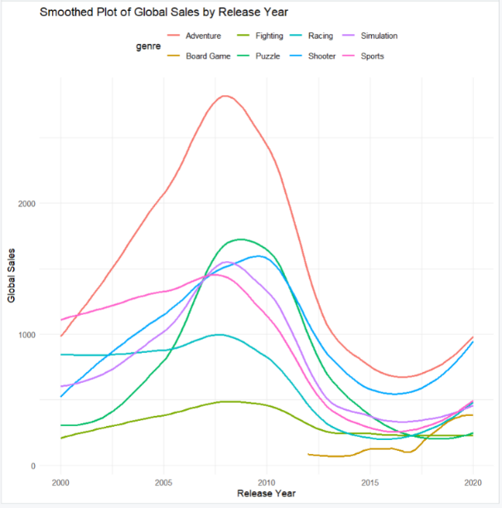

**Publishers that covered most of the game genres**

Even though companies like Bandai, Crave covered many game genres they were not able to produce many games when compared to Activision , electronic Arts. This maybe due to size of the company or the games they choose to develop.

**TOP 15 Publishers by Overall Sales**

The graph below shows the top 15 publishers with highest global sales in millions , the companies shown in this graph are top notch that produce more games and the labels on the bars indicate the number of games developed by these publishers.

From this graph we can notice that Sony had highest sales with 45 games. Although Electronic Arts developed highest number of games that is 461, the overall sales for this publisher are less. By this we can relate that the number of games developed by a publisher does not necessarily correlate directly with their overall sales figures. And also Sony had highest sales in 2010 because they were developing more number of games in emerging markets like Adventure, Sports, Racing and most of these markets had less competition during that period leading to more sales.

Let’s Visualize the overall sales of the top 15 publishers by breaking down their sales into different genres.

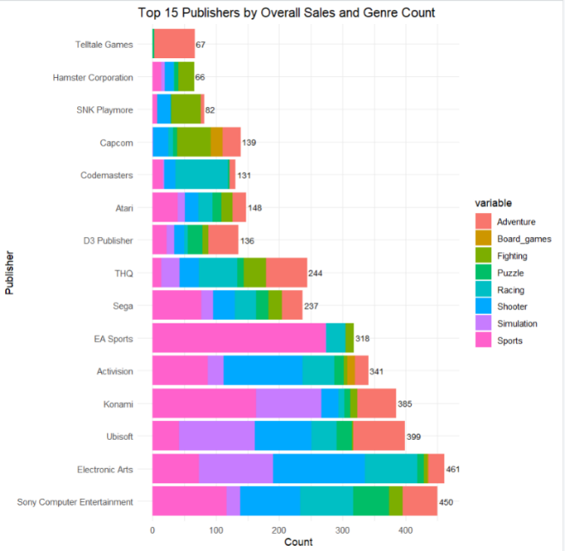

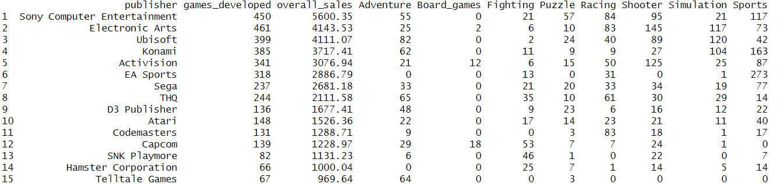

From the above visualizations it can be perceived that every publisher is producing more number of games in a genre they are experts at when compared to other genres because of high competition with expert companies in that genre

If we look at the sales of these top 15 publishers in 4 major regions each region has contributed same amount of sales between 24-26% of their overall revenue.

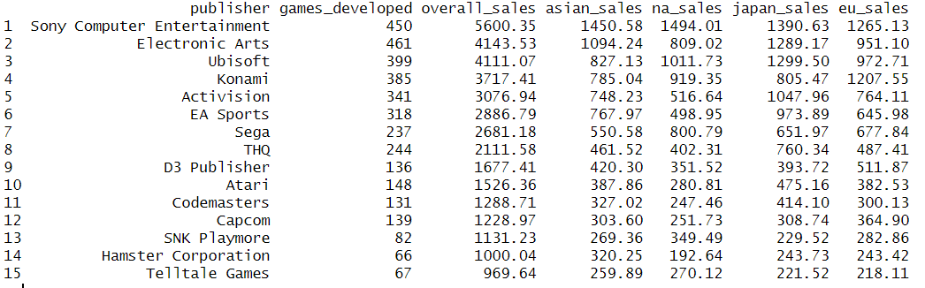

**SALES PER REGION OVER YEARS**

From the above table we observed that the top 15 companies had similar percentage of revenue from different regions but the overall revenue for gaming industry was high from Asia in recent years. And Asia with all other regions had consistent sales till 2015 but after that Asia had significant increase in sales.

5

The sales of video games in those regions as driven by factors like ratings for those games. By doing a correlation test between critic scores and regions, it can be viewed that the probability of sales in each region is effected by the ratings of user, critic and vg.

**ANALYSIS OF SALES IN CONSOLES**

Every game can be released on multiple consoles if we look after overall sales of every platform PC has the highest sales among all the platforms followed by PS2, PSN, and DS. And PC had more sales for Adventure and Shooter games and had less sales for board game, fighting, racing and sports. Whereas PS2 had high sales for racing games.

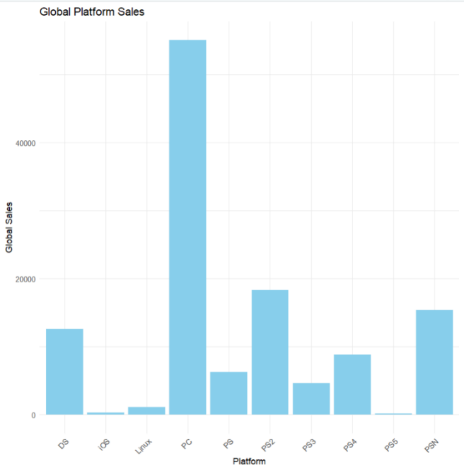

As it can be observed from the below plot that even though the top 10 games published for PC had comparatively less sales compared to other platforms these publishers still continued to produce games for this platform since the player base on PC is high. This makes that PC’s are assumably less effort platforms to develop games.

And also the overall sales for play station was less but the games developed by top publishers had higher average sales in that console.

Even though PC games had a greater number of sales, most of the top publishers preferred PlayStations for publishing their games.

**ANALYSIS OF SALES IN REGIONS**

From this breakdown of console sales in regions, we can observe that Asia had the highest number of PC sales indicating a high number of PC players while PS5 and IOS had the least players. Because PS5 was launched at end of 2020 and IOS making difficult platform to release games because of frameworks and API.

Despite Asia having highest number of video game sales it is not having leading sales in any genre this indicates that having consistent sales in all genres in one region can lead to improved sales.

**SALES OF VIDEO GAME GENRES IN EACH YEAR**

The overall dominating genre is always the adventure. Most of the genres picked up sales from 2008 to 2010 leading to sudden down fall from 2011 to 2013 due to technological limitations or change of perceptions on gaming industry. Even after the downfall adventure had a significant increase in sales when compared to remaining genres. In recent years Adventure and Sports are overall leading genres.

From the above plot while board games were slowly contributing to industry. They had significant sales for even less number of games, Which can motivate new indie developers in this industry.

By viewing the global sales, critic scores on different consoles for different regions on single plot. we can analyse that the overall average sales are high for PC and PS3 making them the most preferred platform for playing games and Asia is the country were games are more popular irrespective of the platform while proving that Asia sales does not have relation to the ratings produced by critic score.

t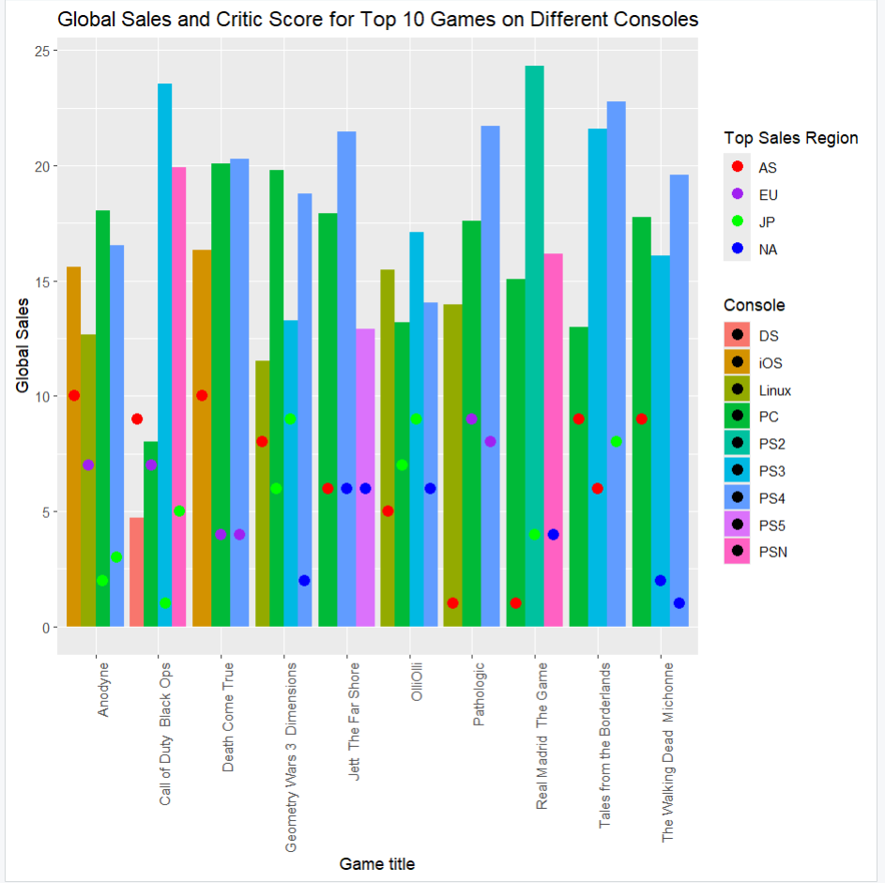

**CONCLUSION**

In conclusion, developing games in Adventure and Sports have a chance of producing more sales in all the regions. since there are lot of games in these genres the competition in these areas is very high which makes it more difficult for a game to get popular. And I feel that developing games for PC,PS3,PS4 in less competitive genres like fighting, board etc can help games in getting high recognition in turn increasing the popularity for publishers. From the overall analysis Asia had high number of video game sales when compared to other regions irrespective of genre making it as the first step to test any kind of genre and as well for gaining sales.